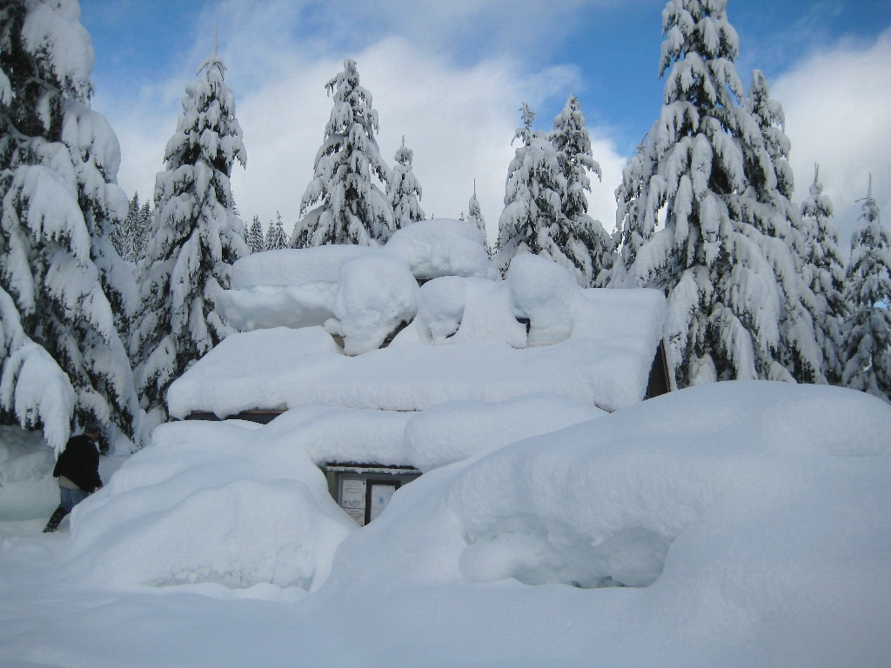
Sun | Mon | Tue | Wed | Thu | Fri | Sat
 |  | 1 | 2 | 3 | 4 | 5
6 | 7 | 8 | 9 | 10 | 11 | 12
13 | 14 | 15 | 16 | 17 | 18 | 19
20 | 21 | 22 | 23 | 24 | 25 | 26
27 | 28 | 29 | 30 | 31
Notes:
Jan 01 : New Year’s Day
Jan 21 : Martin Luther King Day
January 2013


Notes:
Feb 18 : Presidents’ Day
February 2013
Sun | Mon | Tue | Wed | Thu | Fri | Sat
 |  |  |  |  | 1 | 2
3 | 4 | 5 | 6 | 7 | 8 | 9
10 | 11 | 12 | 13 | 14 | 15 | 16
17 | 18 | 19 | 20 | 21 | 22 | 23
24 | 25 | 26 | 27 | 28

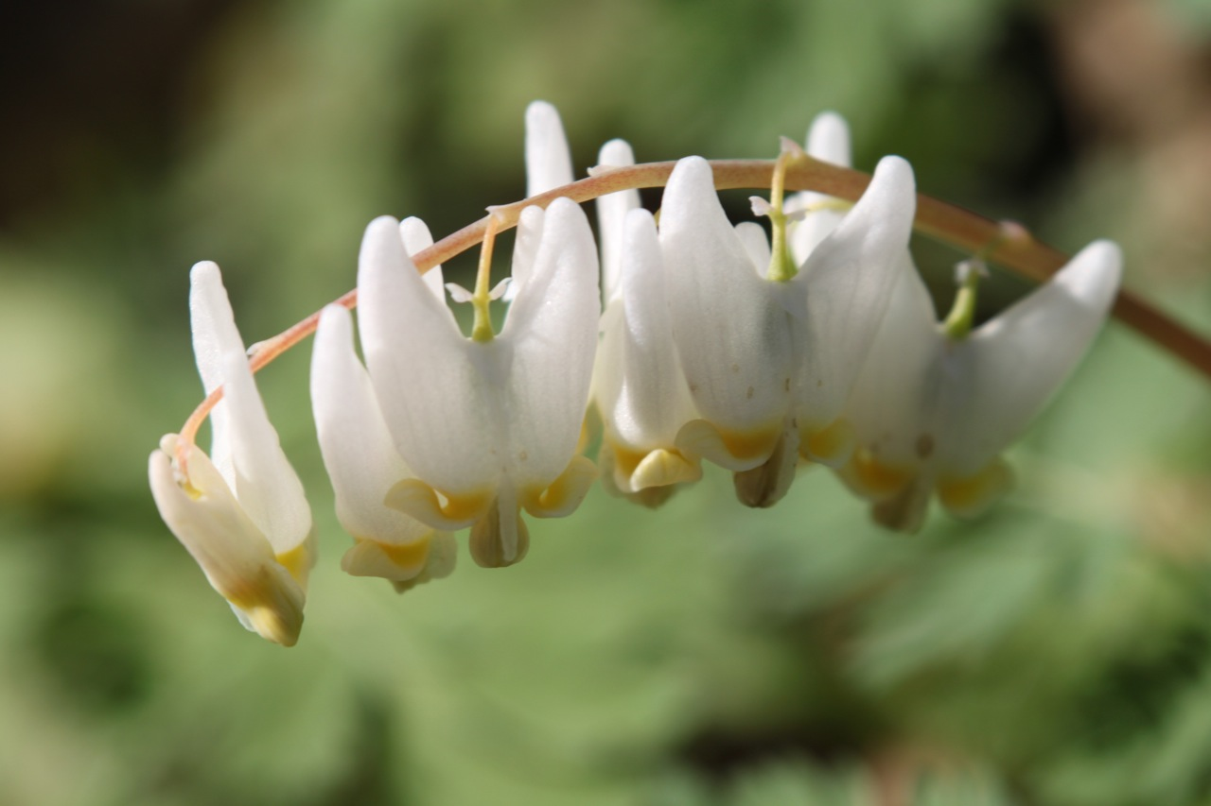
Sun | Mon | Tue | Wed | Thu | Fri | Sat
 |  |  |  |  | 1 | 2
3 | 4 | 5 | 6 | 7 | 8 | 9
10 | 11 | 12 | 13 | 14 | 15 | 16
17 | 18 | 19 | 20 | 21 | 22 | 23
24 | 25 | 26 | 27 | 28 | 29 | 30
31
March 2013
Notes:
Mar 29 : Good Friday


April 2013
Sun | Mon | Tue | Wed | Thu | Fri | Sat
 | 1 | 2 | 3 | 4 | 5 | 6
7 | 8 | 9 | 10 | 11 | 12 | 13
14 | 15 | 16 | 17 | 18 | 19 | 20
21 | 22 | 23 | 24 | 25 | 26 | 27
28 | 29 | 30
Notes:


May 2013
Sun | Mon | Tue | Wed | Thu | Fri | Sat
 |  |  | 1 | 2 | 3 | 4
5 | 6 | 7 | 8 | 9 | 10 | 11
12 | 13 | 14 | 15 | 16 | 17 | 18
19 | 20 | 21 | 22 | 23 | 24 | 25
26 | 27 | 28 | 29 | 30 | 31
Notes:
May 12 : Mother’s Day
May 27: Memorial Day


June 2013
Sun | Mon | Tue | Wed | Thu | Fri | Sat
 |  |  |  |  |  | 1
2 | 3 | 4 | 5 | 6 | 7 | 8
9 | 10 | 11 | 12 | 13 | 14 | 15
16 | 17 | 18 | 19 | 20 | 21 | 22
23 | 24 | 25 | 26 | 27 | 28 | 29
30
Notes:
Jun 16 : Father’s Day


July 2013
Sun | Mon | Tue | Wed | Thu | Fri | Sat
 | 1 | 2 | 3 | 4 | 5 | 6
7 | 8 | 9 | 10 | 11 | 12 | 13
14 | 15 | 16 | 17 | 18 | 19 | 20
21 | 22 | 23 | 24 | 25 | 26 | 27
28 | 29 | 30 | 31
Notes:
Jul 04 : Independence Day


August 2013
Sun | Mon | Tue | Wed | Thu | Fri | Sat
 |  |  |  | 1 | 2 | 3
4 | 5 | 6 | 7 | 8 | 9 | 10
11 | 12 | 13 | 14 | 15 | 16 | 17
18 | 19 | 20 | 21 | 22 | 23 | 24
25 | 26 | 27 | 28 | 29 | 30 | 31
Notes:

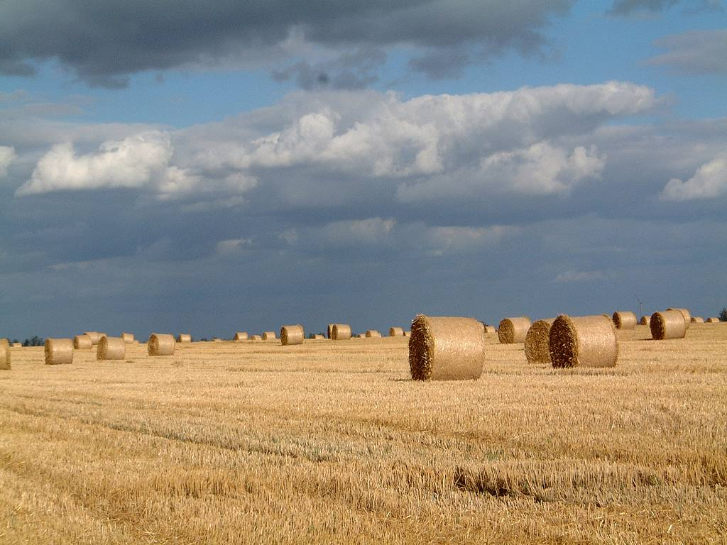
September 2013
Sun | Mon | Tue | Wed | Thu | Fri | Sat
1 | 2 | 3 | 4 | 5 | 6 | 7
8 | 9 | 10 | 11 | 12 | 13 | 14
15 | 16 | 17 | 18 | 19 | 20 | 21
22 | 23 | 24 | 25 | 26 | 27 | 28
29 | 30
Notes:
Sep 02 : Labor Day

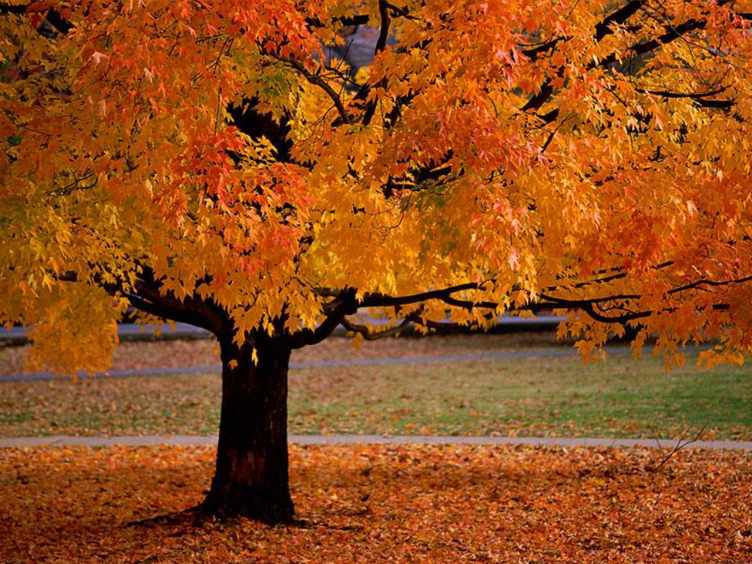
October 2013
Sun | Mon | Tue | Wed | Thu | Fri | Sat
 |  | 1 | 2 | 3 | 4 | 5
6 | 7 | 8 | 9 | 10 | 11 | 12
13 | 14 | 15 | 16 | 17 | 18 | 19
20 | 21 | 22 | 23 | 24 | 25 | 26
27 | 28 | 29 | 30 | 31
Notes:
Oct 14 : Columbus Day
Oct 31 : Halloween


November 2013
Sun | Mon | Tue | Wed | Thu | Fri | Sat
 |  |  |  |  | 1 | 2
3 | 4 | 5 | 6 | 7 | 8 | 9
10 | 11 | 12 | 13 | 14 | 15 | 16
17 | 18 | 19 | 20 | 21 | 22 | 23
24 | 25 | 26 | 27 | 28 | 29 | 30
Notes:
Nov 11 : Veterans Day
Nov 28 : Thanksgiving Day


December 2013
Sun | Mon | Tue | Wed | Thu | Fri | Sat
1 | 2 | 3 | 4 | 5 | 6 | 7
8 | 9 | 10 | 11 | 12 | 13 | 14
15 | 16 | 17 | 18 | 19 | 20 | 21
22 | 23 | 24 | 25 | 26 | 27 | 28
29 | 30 | 31
Notes:
Dec 25 : Christmas Day

